**---------------------------------------------- [CLO 2.1] [CLO 2.2] ---------------------------------------------**

**Total Marks:** 5 Marks

**This project is to be completed by individual student.**

**Purpose:**

The purpose of this project is to demonstrate your understanding of Client side script technologies (XHTML, CSS, and JavaScript), accessibility and good page design by creating a collection of well-structured Web documents.

**Requirements:**

The submission for this project is in the form of a collection of Web pages bound to your personal page with the following structure:

|  |  |
| --- | --- |
| **Header** | |
| **Table of Contents**   * My CV * Favorite Books * My Diary * Feedback form | **[Content Page]**  Your name:  Department:  Class:  Welcome to my site, I hope you enjoy... |
| [**Copyright@uj.2020**](mailto:Copyright@uj.2020) | |

The respective pages for the options available in **"Table of Contents"** will be loaded into the **"Content page"** when the appropriate option is selected in the Table of Contents.

**My CV:**

Display Form that contains the following:

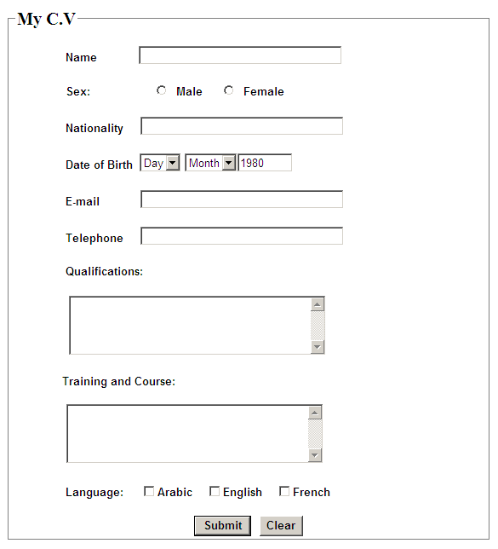

Add Field

**Note:**

* The following fields must have default values(static data) that means you have to set its values (for example):
* Name: Ali Ahmed
* Sex: Male
* Nationality : Saudi
* Date of Birth: 1/1/1980
* For other fields such as (e-mail, telephone, Qualifications, training and language) you must validate them before submit your entries.
* Clicking *Add Field* button allows you to dynamically add fields to your C.V (such as place of birth, tribe, …etc)
* Once you click on the submit button display your full C.V

**Favorite Books:**

This section displays a list of your favorite book titles; once you click on the title it expands and shows the details of the book containing (Author, Publisher, Year, and brief details about the contents). Once you click again on the book title the details are contracted ad become hidden.

* Misery
* The Lord of The Rings
* C++ How to Program
* Harry Potter

Clicking on *Misery* for example will result:

* Misery

Author: Stephen King

Publisher: Addison Wisley

Year: 1978

Review: Whatever… (Complete details)

* The Lord of The Rings
* C++ How to Program
* Harry Potter

**My Diary:**

This section displays an image represents days of the week, when your mouse moves over a specific day, your tasks in that day are displayed in a division of the same page.

|  |  |
| --- | --- |
| Your Diary in Monday:   * + - * Play football       * Watch TV       * Jog a Mile       * Study ☹ |  |

**Feedback Form:**

Display Form that contains the following:

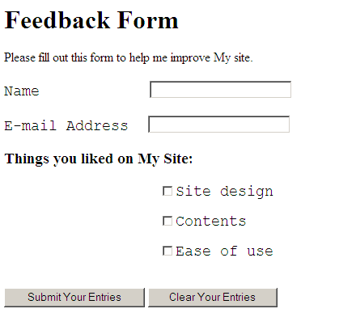

**Note:**

* Validate form's field before submit your entries.
* Once you click on submit display as follow: (for example)

|  |
| --- |
| Thanks "inserted Name(Ali )" for your comments..  Your e-mail: ali@yahoo.com  Things you liked on my site: site design and Contents. |

**Assessment:**

Grades will be determined according to the following:

* All XHTML code must be edited using a text editor (no machine generated pages will be accepted!).
* Following XHTML structure [DOCTYPE, etc..] and valid CSS (external style sheet).
* Proper indentation with comments for all your XHTML Documents.
* Formatting like: Paragraph, headings, lists, font size and color (all using CSS).

**Submission requirements:**

* Use valid XHTML and CSS (external style Sheet)
* Use JavaScript to validate forms
* Files should be well arranged and easy to maintain (separated folders for Images, Scripts, Styles, and any other component of the site)
* Page layout should be maintained totally using CSS (No tables are allowed for page layout)